

Adding DOIs for Books on the WAC Clearinghouse Tools Site
- Visit https://wactools.colostate.edu and click “Log In” on the menu.
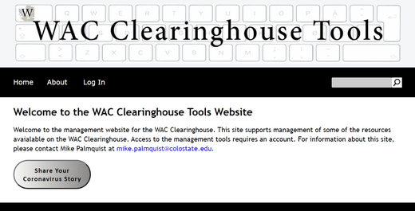
- Once you’ve logged in, click on the DOI link on the menu or on the “Manage DOIs” button in the main body of the page.
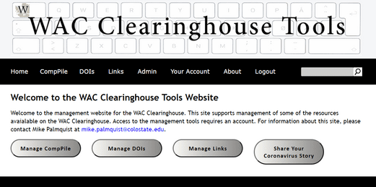

- Click on the “Create a DOI” box in the main body of the page.
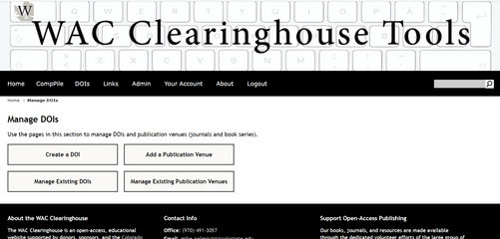
- Complete Step 1 by choosing an authored book or an edited collection. Please note that an edited collection will also involve adding chapters and other book parts (such as a foreword or introduction), while an authored book will not. In both cases, the book will have its own DOI. For edited collections, each chapter or book part will have its own DOI as well.
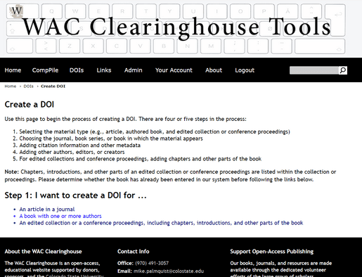
- Choose a book series.
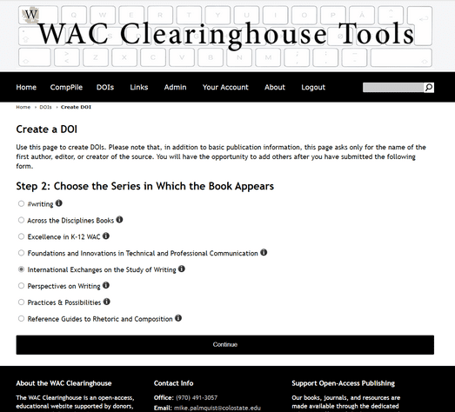

- Complete the form, paying attention to the points made in the Step 7, below. Please note that you can open a second window and display it alongside the DOI form, as follows. Please note as well that you can select text from the book page and drag it into the form fields.
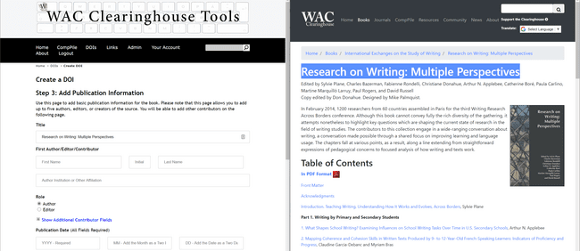

- Complete the form as follows:
- Add the title
- Add the author(s) or editor(s), noting their institutional affiliations and their role (author or editor). If the institutional affiliation is not clear, look for the information in the About the Authors or About the Editors section, below the table of contents. If that does not provide the information, open the “contributors” section or look for that information in the front matter of the book. A contributors section is typically provided in edited collections; it can be found as the last entry in the table of contents on the book page.

- If there is more than one author or editor, click on the “Show Additional Contributors Fields” link. This will open a section where you can add four more authors or editors. In the case of books with more than five authors or editors, you can add the rest of the authors or editors on a subsequent page.

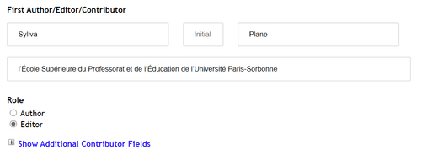
- Enter the publication date, following the directions: four digits for the year, two digits with a leading zero for the month and date. You can locate the year, month, and day information below the table of contents. If there is both a Digital Publication Date and a Print Publication Date, provide the Digital Publication Date.

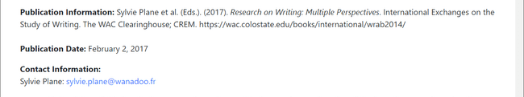

- Enter the URL for the book page. Do not use the URL for the PDF or for the ePub or for individual chapters. You can locate this in the browser or, typically, in the publication Information section (see above).
- Enter the publisher. This will be provided in the Publication Information section. Separate multiple publishers (e.g., The WAC Clearinghouse; University Press of Colorado) with a semicolon. Be sure to enter “The WAC Clearinghouse” rather than “WAC Clearinghouse.”

- Provide the ISBN. This will require you to open the front matter for the book (or the full book). Look for the page that provides the Library of Congress publication information (typically the sixth page of the book). Locate the ISBN for the PDF edition of the book (do not use the print or ePub ISBNs). Copy it and enter it into the ISBN field. If the ISBN includes dashes, remove them.

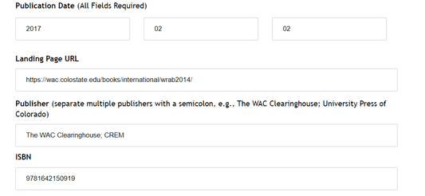

- Save your work by clicking on the Continue button at the bottom of the page. The website will save the information you have provided (the metadata) and generate a unique DOI for the book. You will be taken to the DOI Details page. Use the options on this page to update the book information, to add or update authors or editors, and to add (in cases of edited collections) chapters or other book parts.

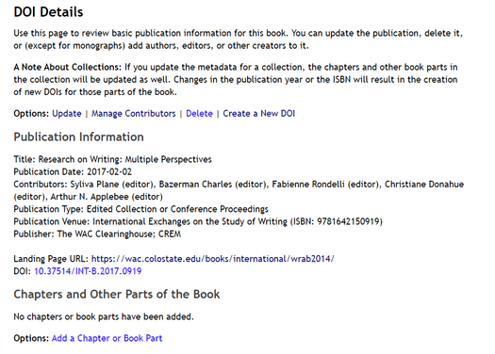
- To add a chapter, click on the Add a Chapter or Book Part link.
- Enter the information for the chapter. You will be asked only for the title, the authors and their affiliations, the page numbers, and the book part (introduction, chapter, and so on). Provide a two digit chapter number that includes a leading zero for the first nine chapters. You will need to open the PDF file to locate the first page and last page of the chapter or book part. Roman numerals are allows for front matter. Please note that you should include Chapter 1 or Chapter 2 if it is part of the title. If it is not, as is the case with the International Exchanges series, leave the number out.

