

Notes for Creating ePubs
Before the ePub InDesign File is Created
Accessibility in the PDF and ePub
- Be sure that all of the images (figures) in the document have alt tags. Use the figure captions for each tag.
- You can add alt tags by [Right Click] and then select Object Export Options. In the dialog, go to the Alt Tag section, choose Custom from the Alt Text Source dropdown, and enter the text for the tag. (Note: InDesign automatically adds an empty alt=”” tag to the code of all images placed into the document.)
Preparing Hyperlinks
- Be sure that all of the URLs in the parent document are active before you have saved the ePub InDesign file. Open the Hyperlinks panel in InDesign, then search for http and see if each link is live. If not, create it in the panel by selecting the URL (excluding any end of paragraph markers) and clicking on the create hyperlink from URL button at the bottom of the panel (it should be the second item and will look like a page icon).

After the ePub InDesign File is Created
Style Changes
- Create a new style that will allow splitting in the front matter (call it Front Matter Heading). For SWR books, use the existing Works Cited & EM/FM Headings style.
- Go to the Paragraph Styles box, click on the quick arrow (on the right side of the dialogue box), and choose Edit All Export Tags. Then select the split document option for book title, chapter titles, section titles, and any front matter styles (e.g., Front Matter: Front Matter Header, Front Matter: Series Title, Front Matter: Dedication, and for SWR books, the Works Cited & EM/FM Headings) you want to use.
- In case it’s not already done, use the Edit All Export Tags dialog to set up the heading levels for purposes of accessibility. Generally, I’ve started ignoring the Front Matter: Book Title heading, which I used to set as H1. Instead, do something like this:
  - H1 – Section Title (if sections exist, otherwise Chapter Title), Front Matter Heading (along with Series Title if you're not replacing them with Front Matter Heading). Make sure these h1 headings are set to split the document in the ePub section.
  - H2 – Chapter Title. Make sure this style is set to split the document in the ePub section.
  - H3 – Heading A
  - H4 – Heading B
  - H5 – Heading C
  - H6 – Heading D
- In the Edit All Export Tags dialog, assign HTML5 tags to the following styles. You can do this by highlighting “automatic” and typing in the tag.
  - Figure: figure
  - Figure Caption: figcaption
  - Block Quotation Styles (all of them): blockquote
  - Section Break: hr
  - Emphasis: em
  - Citation: cite
  - Strong: strong
- Set the keep options in styles as follows:
  - In the Body Text: Figure Captions style. Keep with Previous.
  - In Body Text: Table Title style. Keep with the next three lines.
  - In the Headings (A, B, and C) styles. Keep with the next two lines.
- If you are using a book from the International Exchanges or #writing series, remove the Drop Cap options from the Chapter Title style. Add a tab at 6p0.
- If you are using a book from the Precarity Series, set the left indent for section and chapter titles to zero.
Table of Contents
- Create a new TOC Style (do not load a previous style, even from the same series, since it might overwrite some changes you’ve made to the document styles).
  - Typically, just rename and edit the existing WAC Clearinghouse TOC style from the PDF/print version of the book. Name the TOC style WAC Clearinghouse ePub TOC.
  - Set the Title of the TOC to Contents and set the style to Front Matter Heading or, for SWR books, the Works Cited & EM/FM Headings. Use the Standard TOC styles for the book you’re using, but remove the page numbers.
  - Make sure you set the options as shown below:
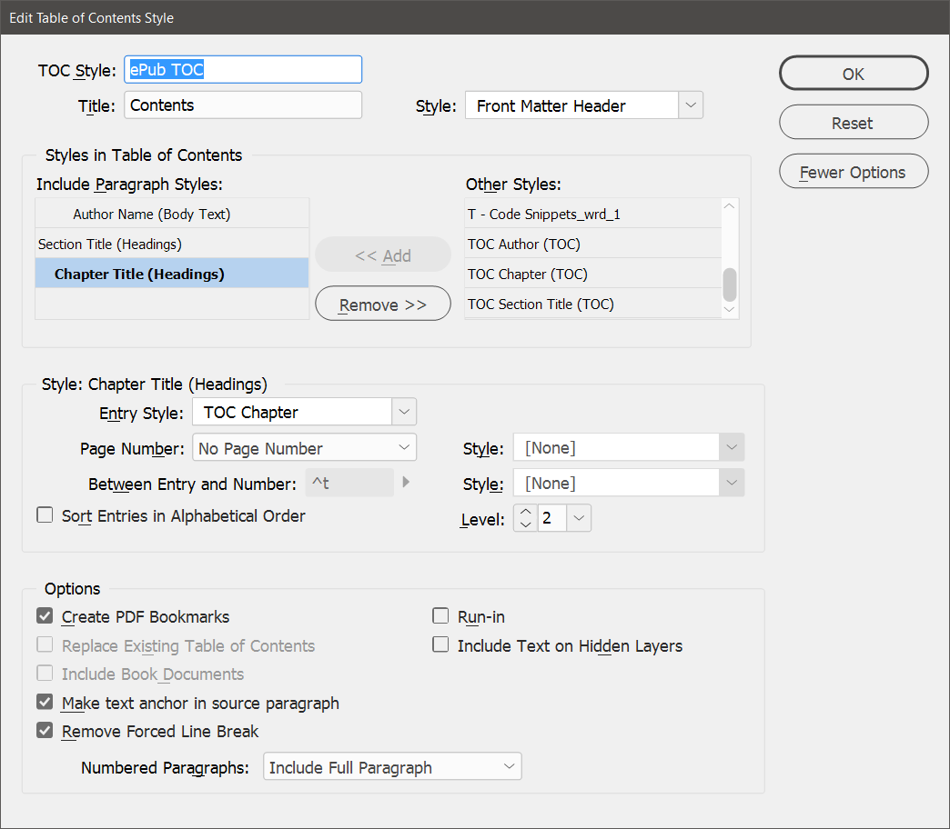

Note that it might be necessary to change the tabs and left/first line indents to make the TOC display reasonably well.

- Remove any font-size changes from the chapter titles (mostly for the Perspectives series). Search for specific font sizes and clear overrides.
- For the #writing series, change the tab location in the Chapter Title heading to 1p6.
- For the International Exchanges series, add a tab to the Chapter TOC style at 1p6. Set the left indent to 1p6 and the first line indent to -1p6.
- For the SWR series, set the Contents title style to the Works Cited & EM/FM style.
- Generate the TOC.
- If the author names are centered, change them to flush left. You might want to make them italic. Or you might make them indented by 1 pica.
Layout Issues
- Remove the text box from the first page of the document. Place the cover PDF and have it cover the page. You’ll need to crop it on the left side of the image.
- Add an ALT tag for the cover image. Generally, use “Cover Page for Book Title, by / edited by …”.
- Move the original third page (title, authors/editors, and publishers) to the second position, before the series page.
- If the book has a subtitle, replace the paragraph break with a line break. This will prevent the title and subtitle from starting on separate pages. Make sure the entire paragraph is still set with the Front Matter - Book Title style.
- Remove indents from Chapter Title (older books).
- For the SWR series, delete the opening paragraph break and the underlined chapter number at the start of each chapter. Then place the chapter number at the start of the chapter title. The format should be 2. Chapter Title, with a period after the chapter number. The chapter number and title should be in a single paragraph. (Note: You’ll need to regenerate the TOC after this is one.)
- If you are using a book from the Precarity Series, remove the logo image from the start of the section and chapter titles.
- Delete all of the parent spreads except Master blank.
- If you’re working with an older book, make some changes to the Publication Information page (where the Library of Congress Info appears):
  - Add Publication Information to the top of the page and style it as Front Matter: Front Matter Heading (or the alternate for a given series, see above).
  - Remove any notes on the Publication Information page regarding printing on acid-free paper.
  - If Printed in the United States is used, change it to Produced in the United States.
- Remove all page breaks. Replace with end of paragraph marks that use the body text style. Then check for empty paragraphs that are styles as Section Titles or Chapter Titles. These will add blank pages to the book.
- If any figures, photos, or tables are not set in the flow of the text, change them to anchored objects in the flow of the text. The default paste options should work. If not, then use the first option (inline or above the line) and set the Y offset to the first increment (usually .0625 inches or 0p6 points). For the SWR books, you should move the sections at the end of the book (bios and other books in the series) into the main text.
- For the SWR series, delete any photos on the author info page.
- For the SWR series, use the title page text from a previous book in the series. Then remove all the lines in the front matter—because of the older design, they are all set outside the flow of the text.
- Remove any DOI identifiers for chapters or other book parts. These show at the bottom of pages in the PDF, but they move when the book is reformatted for ePub format and are not needed in the ePub. (These will not disappear when you remove the master pages; we break them out as independent text boxes when we edit them.)
- Remove all tracking changes introduced to control print layout. You can simplify this by selecting all text and setting the tracking to 0. Or you can use Find / Replace looking for tracking of -5, -10, +5, and +10 and changing them to 0. You’ll still have some to change, but it will take care of most of it. To show tracking and kerning, go to Preference / Composition and find the checkbox that will turn it on. You’ll see light green for tracking that is part of a style (and thus something you want to keep) and dark green for manual changes to tracking.
- Don’t worry about page numbers or headers. They don’t transfer.
- Note: Do not worry about the following until Adobe fixes its footnote numbering. At this point, no matter what you do (short of adding each chapter as a distinct story), footnote numbers are continuous throughout the document. If you have footnotes or endnotes in an edited collection or conference proceedings, remove existing section breaks and then add new ones at the beginning of chapters that use notes. (This typically does not need to be done for authored books, where footnotes number consecutively.) Then use the options in the next section to show them as popups (assuming you are using the ePub 3 standard). This will allow footnotes and endnotes to have the correct numbering. (It might be easiest to delete all section breaks and then search for the Chapter Title style to add new section breaks.)
- If an index exists, regenerate it.
- If you are working with an SWR book, check the back matter (especially the list of previously published books) and make sure no text is set outside the flow of the main text. For example, the book list is set two columns with the list title set above it in a separate text box. Change that.
Export Settings
- Use the ePub 3 settings.
- Choose “none” for what to do with the front page.
- In the ePub creation dialogue box (first page), specify the new ePub TOC style you created earlier.
- On the Advanced tab, change the Split Document setting from “Do Not Split” to “Based on Paragraph Style Export Tags” (top of the dialogue box) and specify the TOC style you created earlier.
- Change footnote placement to Popups.
- Map bullets to unordered lists.
- Map numbered lists to ordered lists.
- In the Object settings dialog, set the CSS options as follows:
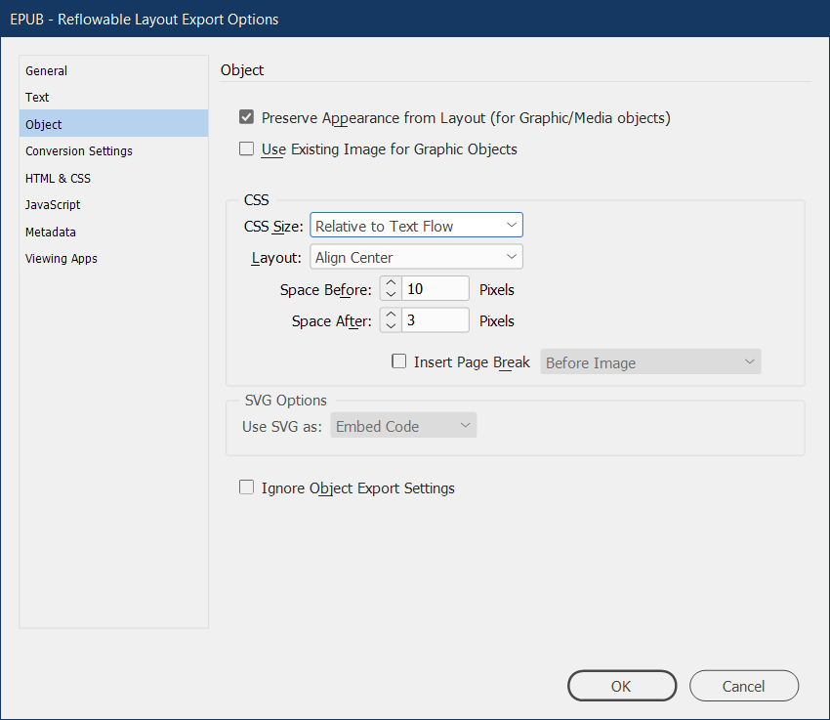
- Include the epub.css stylesheet (found in the Books folder)
- On the Advanced tab, add metadata:
  - Identifier: Leave as the default provided by InDesign
  - Title: Book Title
  - Creator: Book author(s) or editor(s)
  - Date: Current Date
  - Description: Add the following info from the web page.
    - Author(s) or Editor(s)
    - Copyeditor and book designer(s)
    - Back cover copy/description
    - About the author(s)/editor(s)
    - Publication Info (citation on the web page)
    - Pub dates for print and epub/pdf editions.
  - Publisher: The WAC Clearinghouse and University Press of Colorado (or just the Clearinghouse, depending on the series)
  - Rights: Here’s a sample to model off: Copyright © 2015 Theresa Lillis, Kathy Harrington, Mary R. Lea, and Sally Mitchell. This work is licensed under a Creative Commons Attribution-Noncommercial-No Derivative Works 4.0 United States License. 440 pages, with notes, illustrations, and bibliographies. Available in print format direct from University Press of Colorado online, or at any online or brick-and-mortar bookstore. Available in digital formats for no charge on this page at the WAC Clearinghouse. You may view this book. You may print personal copies of this book. You may link to its webpage. You may not reproduce this book on another website.
  - Subject: Some keywords

Post Production
Check the ePub for any layout problems in Calibre. If you see any, correct the errors in the InDesign file and regenerate the ePub.
Once the ePub has been exported, it must be checked using Daisy’s Ace app and then edited using Dreamweaver. Consult https://www.accessiblepublishing.ca/epub-semantic-aria-roles/ to learn about applying ARIA roles to the document.
- Daisy’s Ace app can be downloaded from https://daisy.github.io/ace/getting-started/ace-app/#where-can-i-download-the-ace-app.
- Calibre can be downloaded from https://calibre-ebook.com/.
Open Ace. Drop the ePub into the app. Work through the report to identify areas that need to be changed using Dreamweaver.
Open Calibre. You can make global edits by opening the edit tool and then opening each of the xhtml files.
Important Note: It is likely useful to save the ePub file with a name such as draft1.epub rather than the name you’ll use for the file on the website. When you are done editing in Calibre, save the file, and then save a copy to the ePub folder in the book you are working on (e.g., Clearinghouse/books/perspectives/inoue/epub/writing.epub.
Run Search and Replace on the xhtml files. The primary edits to be made post-production are:
- Replace the beginning of the HTML code in the head of the xhtml files. This includes the TOC file (in Calibre, this is found in an area below the list of xhtml files).
<?xml version="1.0" encoding="UTF-8" standalone="no"?>
<!DOCTYPE html>
<html xmlns="http://www.w3.org/1999/xhtml" xmlns:epub="http://www.idpf.org/2007/ops">
<head>

Should be replaced with:

<?xml version="1.0" encoding="UTF-8" standalone="no"?>
<!DOCTYPE html>
<html lang="en" xmlns="http://www.w3.org/1999/xhtml" xmlns:epub="http://www.idpf.org/2007/ops">
<head>
<metadata>
<meta property="schema:accessibilitySummary">This publication conforms to WCAG 2.0 Level AA. </meta>
<meta property="schema:accessMode">textual</meta>
<meta property="schema:accessMode">visual</meta>
<meta property="schema:accessModeSufficient">textual,visual</meta>
<meta property="schema:accessModeSufficient">textual</meta>
<meta property="schema:accessibilityFeature">structuralNavigation</meta>
<meta property="schema:accessibilityFeature">alternativeText</meta>
<meta property="schema:accessibilityHazard">noFlashingHazard</meta>
<meta property="schema:accessibilityHazard">noSoundHazard</meta>
<meta property="schema:accessibilityHazard">noMotionSimulationHazard</meta>
</metadata>

Note: The TOC.xhtml file might have to be done individually.

- Open the Content.opf file and add the following metadata tags to it (below the opening package tag):

<meta property="schema:accessibilitySummary">This publication conforms to WCAG 2.0 Level AA. </meta>
<meta property="schema:accessMode">textual</meta>
<meta property="schema:accessMode">visual</meta>
<meta property="schema:accessModeSufficient">textual,visual</meta>
<meta property="schema:accessModeSufficient">textual</meta>
<meta property="schema:accessibilityFeature">structuralNavigation</meta>
<meta property="schema:accessibilityFeature">alternativeText</meta>
<meta property="schema:accessibilityHazard">noFlashingHazard</meta>
<meta property="schema:accessibilityHazard">noSoundHazard</meta>
<meta property="schema:accessibilityHazard">noMotionSimulationHazard</meta>

- If the book contains footnotes, do the following:
  - Search for epub:type="noteref" Replace it with epub:type="noteref" aria-label="footnote reference"
    - Note: if you don’t find this one, search for the backlink. It might look something like this: <a class="_idFootnoteLink If so, replace it with <a aria-label="footnote reference" class="_idFootnoteLink
  - Search for epub:type="footnote" Replace it with epub:type="footnote" aria-label="footnote text"
  - Search for backlink"></a Replace it with backlink" aria-label="footnote backlink"></a
  - Note: This might not be something you can find.
Note: ACE will ask for unique identifiers for every footnote reference (the superscripted number). This is considered a minor error. Do not fix this.
- Just in case, check for any nested links by searching for </a><a href= This has shown up occasionally. It might be an InDesign issue (overlapping links, perhaps).
- Save the file to the folder where the InDesign file is located.
- Go into the folder that it created, then copy the ePub file to the top of the folder, test it, and repeat the process if needed.

