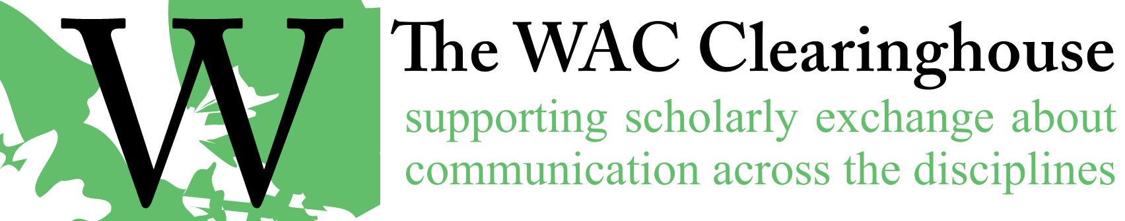

Notes for Preparing the Manuscript for Production
Generally, begin by working within Word and then place the file into InDesign. Most of the editing of the manuscript should take place in Word.
- Style Import. If it has not been done yet, import styles from a previous “ready for production” file.
- Style Application. If this wasn’t done in copyediting (it should have), you’ll need to do a number of things.
  - Make sure all chapter titles, author names, author affiliations, headings, block quotes, and reference lists are styled appropriately. We use Heading A, B, and C for headings.
  - Switch to the “View Styles in Use” setting in Word (shown in the options at the bottom of the right side styles box in Word).
  - Replace extraneous styles with those in the WAC style set. You can right-click on the style and select all instances, then click on the appropriate style to apply it to the selected passages.
  - Delete the extraneous styles.
- Strong and Emphasis Character Styles. Replace all bold text with the character style “strong”. You should probably limit the replacements to text in the normal, normal-no indent, and blockquote styles. You should also search across numbered and bulleted lists. Replace all italicized text with the character style “emphasis.”
- Spaces. Get rid of all double spaces (except where they’re actually needed, such as in the layout of text-based figures).
- Tabs. Get rid of them, except when they are absolutely necessary.
- Extra Line Breaks. Get rid of them. Control spacing through styles (or paragraph settings if absolutely necessary).
- Numbered and Bulleted Lists. Use them. Don’t use numbers and tabs, for example.
- Ellipsis Marks. Use three periods (or four at the end of a sentence). Do not use ellipsis marks. Place a space after each period.
- APA and MLA Documentation Systems. If there is a mix of systems, choose the appropriate style for the overall book and convert the least-used style to the most-used style. Use the appropriate section heading for Works Cited or References lists. This should be styled as Heading A.
- Hyperlinks. Ensure that all hyperlinks are live.
- MLA and APA Style. Check rigorously for mistakes in citations. These can occur in-text (with unneeded page numbers in APA style, lack of spaces between author initials in APA style, lack of commas after author initials in APA style, or failure to use ampersands in place of “and”). They can also occur in the references and works cited lists. There are numerous problems that occur at this stage. If necessary, return the file to the editors or authors. Note URLs and DOIs as well. Even with MLA style, we prefer to include hyperlinks (for the full URL or for https://doi.org/DOIString). The links should be live when they are placed in InDesign. Be sure that periods are included after URLs in MLA.
- Endnotes and Footnotes. Whenever possible, use footnotes. Do not worry about section breaks. Those will be added in InDesign. If you have an endnotes section, use the heading “Notes” with a style set to Heading A. The section should appear before the Works Cited or References list.
- Sections. Be sure to put page breaks between each chapter and part title page.
- Figures. Be sure the copyeditor has made sure that we’re using Figure x.x format (e.g., Figure 2.1). Figure titles should be set up as Figure 2.1. This is the caption.
  - If Word has been used to create figures, zoom to the largest size possible, capture the screen, and paste the screen shot into a graphics editing program. Crop the image as appropriate. Size it to 4.625 inches at 600 dpi using a color space of CMYK. Save the file. Place an “Insert Figure X About here” notice at the appropriate spot in the file and remove the figure from the file.
  - If the figure is a graphics image, remove it from the document and save it with an appropriate name in the format defined above. Be sure to add the Insert notice in the manuscript.
  - Be sure to look for “below” and “above” and similar placement references. We typically remove those because it’s sometimes the case that they are inaccurate.
  - Ensure that ALT tags have been provided. If they are not available, plan to use the figure captions.
- Tables. Be sure the copyeditor has made sure that we’re using Table x.x format (e.g., Table 2.1). Table titles should be set up as Table 2.1. This is the title. In InDesign, we have a Table Title style in the Body Text group. Similarly, there are Table Text, Table Header, and Table Notes styles.
- Dashes. You should replace En-Dashes that are used as hyphens with hyphens. You should replace double hyphens with Em-Dashes. Do not put spaces on either side of the Em-Dashes.
- Epigraphs. If you find an epigraph at the beginning of a chapter or section or subsection, use the epigraph style and set the attribution flush right (using the epigraph source style) with an en dash or hyphen (be consistent) using the epigraph source style:
Teachers in the disciplines who are told they do not need to know about grammar in order to use writing in their classes feel betrayed when faced with a non-native speaker’s grammatical and syntactic tangles in a writing-to-learn assignment. Many WAC directors themselves feel at the edge of their competence in dealing with such situations.
- Susan McLeod & Eric Miraglia, 2001
- Author Affiliations. If author affiliations are missing (for example, in an edited collection), please try to find them. They are often in a list of contributors. This should be picked up in copyediting, but it doesn’t always happen.
- Contributors Section. If one is provided, follow the pattern from a previously published book. Generally, use a construction such as “Jane Doe is Professor of English at …” (rather than “a professor of English at …”). Capitalize formal titles, such as Director, Associate Director, Coordinator. Do not capitalize doctoral candidate, researcher, postdoctoral researcher, etc., but do capitalize Postdoctoral Fellow.
In InDesign
- Make sure that ellipsis marks do not break.
- Make sure you add the DOIs for chapters in edited collections.

