

Notes for Working with Scanned PDFs
Summary. Create a new copy of the book and name it something like bookname-archival.pdf. Then remove the covers. You will size them and edit them later in Photoshop. You will need to ensure the page sizes are equal across the document, that page numbering in Acrobat aligns with page numbers on the document, and that the cropping of the pages eliminates any shadows created during the scanning process. Then you’ll save the document in archival form. Finally, you’ll optimize the scans, add in the updated cover images, and save the file as a working file (smaller sized for use on the web).
- Create a new folder called Web.
- Save the file with the Library scan name.
- Save the file within the Web folder, using the form bookname-archival.pdf.
- Extract the front and back covers. Save them as Cover Front and Cover Back (and any inside jacket materials as well).
- Export the covers to JPG format (150 dpi).
- Save the file.
- If the book came in with uneven page sizes, increase the size of the page to a larger size, such as Letter or a custom size, and then crop all pages to a smaller size. The following example shows a scan that had been set at letter size and then cropped to 9 x 6.5. Note that the new size must be larger than the largest page in the document. Note as well that doing this will not add substantially to the size of the file.
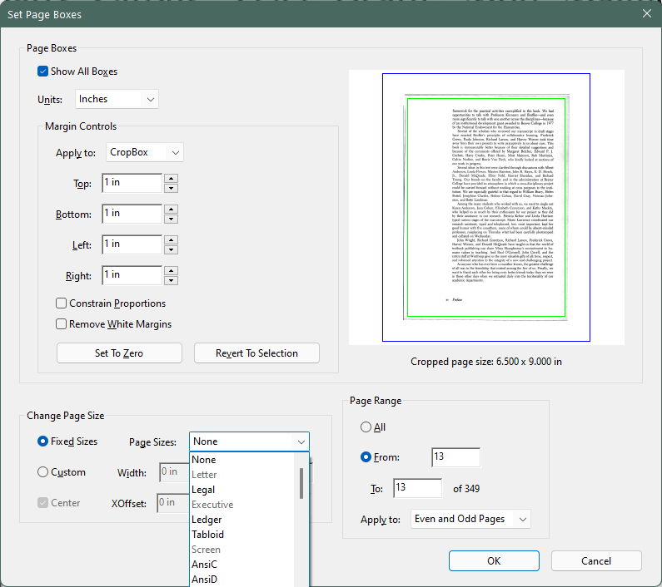
- Crop the pages so that the shadows produced during scanning are removed.
- If needed, edit the pages to remove unneeded images (background and foreground, such as written names on a page near the front of the book).
- In Photoshop, adjust the size of the exported Front Cover and Back Cover images to match the new size of the pages in the book. Use the healing brush to clean up imperfections in the cover.
- Save the JPG files.
- Save the front cover as cover.jpg. Resize it to 150 dpi 450 x 675 pixels.
- Insert the front and rear cover images into the PDF file. If appropriate, recognize text on the images. Insert a blank page after the front cover. Add page labels to the cover and blank page (typically CoverA and CoverB).
- Save the file.
- Then check that no blank pages have been left out (to ensure that the pagination is correct). Be sure to set up the page numbering in the front of the document. Generally, front matter uses Roman numerals and the body uses Arabic numbers. Add blank pages as needed to ensure appropriate pagination.
- Save again.
- Save the file as a new file using the convention bookname.jpg.
- When the file opens, choose the Optimize tool. Do not optimize the entire book. Instead, use the Optimize Scanned Pages tab with the following settings. If the document does not already include recognized text, you can turn on the option to recognize the text. If the OCR process has already been run, clear that option.
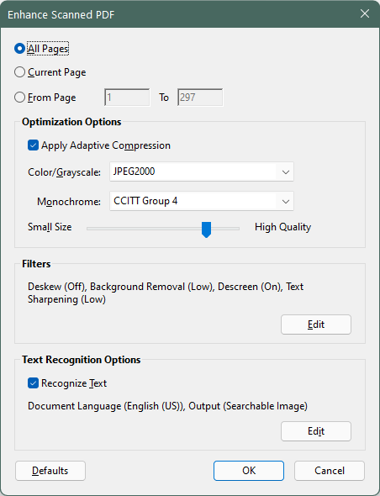
- Save the file.
- The book should now be ready for web production. Extract pages to create front matter, chapters, and so on.

